Works – 8 – Due particelle in rotta di collisione in uno spazio AdS (Two particles on a collision course in a AdS space)

Due particelle in rotta di collisione in uno spazio AdS N
(Two particles on a collision course in a N AdS space))
2009
Catalytic paint on laser cut steel sheet
120 x 250 cm
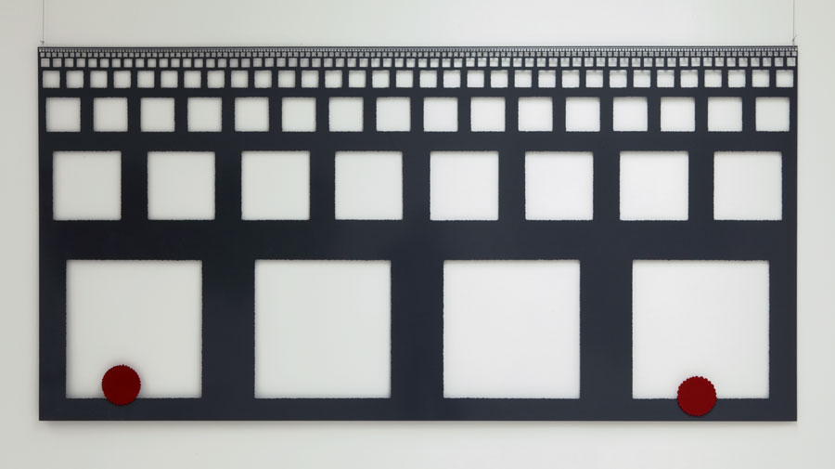

Due particelle in rotta di collisione in uno spazio AdS Y
(Two particles on a collision course in a Y AdS space))
2009
Catalytic paint on laser cut steel sheet
122 x 188 cm
